Frame Level Classification of Speech
DUE DATE: 02/12
LAST DATE: 02/19
In this challenge you will take your knowledge of feedforward neural networks and apply it to a more useful task than recognizing handwritten digits: speech recognition. You are provided a dataset of audio recordings (utterances) and their phoneme state (subphoneme) labels. The data comes from articles published in the Wall Street Journal (WSJ) that are read aloud and labelled using the original text. If you have not encountered speech data before or have not heard of phonemes or spectrograms, we will clarify the problem further.
The training data comprise:
- Speech recordings (raw mel spectrogram frames)
- Frame-level phoneme state labels
The test data comprise:
- Speech recordings (raw mel spectrogram frames)
- Phoneme state labels are not given
Your job is to identify the phoneme state label for each frame in the test data set. It is important to note that utterances are of variable length. We are providing you code to load and parse the raw files into the expected format. You can find that code here.

Phonemes and Phoneme States
As letters are the atomic elements of written language, phonemes are the atomic elements of speech. It is crucial for us to have a means to distiguish different sounds in speech that may or may not represent the same letter or combinations of letters in the written alphabet. For example, the words "jet" and "ridge" both contain the same sound and we refer to this elemental sound as the phoneme "JH". For this challenge we will consider 46 phonemes in the english language.
["+BREATH+", "+COUGH+", "+NOISE+", "+SMACK+", "+UH+", "+UM+", "AA", "AE", "AH", "AO", "AW", "AY", "B", "CH", "D", "DH", "EH", "ER", "EY", "F", "G", "HH", "IH", "IY", "JH", "K", "L", "M", "N", "NG", "OW", "OY", "P", "R", "S", "SH", "SIL", "T", "TH", "UH", "UW", "V", "W", "Y", "Z", "ZH"]
A powerful technique in speech recognition is to model speech as a markov process with unobserved states. This model considers observed speech to be dependent on unobserved state transitions. We refer to these unobserved states as phoneme states or subphonemes. For each phoneme, there are 3 respective phoneme states. Therefore for our 46 phonemes, there exist 138 respective phoneme states. The transition graph of the phoneme states for a given phoneme is as follows:
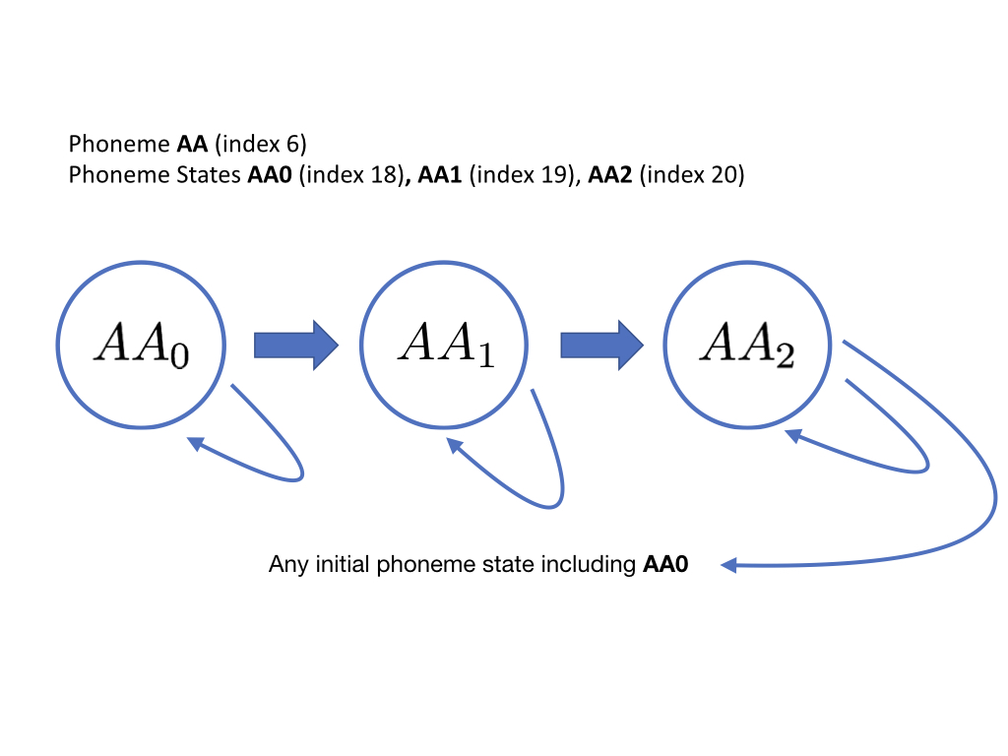
Hidden Markov Models (HMMs) estimate the parameters of this unobserved markov process (transition and emission probabilities) that maximize the likelyhood of the observed speech data. Your task is to instead take a model-free approach and classify mel spectrogram frames using a neural network that takes a frame (plus optional context) and outputs class probabilities for all 138 phoneme states. Performance on the task will be measured by classification accuracy on a held out set of labelled mel spectrogram frames. Training/dev labels are provided as integers [0-137].

Representing speech
As a first step, the speech must be converted into a feature representation that can be fed into the network.
In our representation, utterances have been converted to "mel spectrograms", which are pictorial representations that characterize how the frequency content of the signal varies with time. The frequency domain of the audio signal provides more useful features for distinguishing phonemes.
For a more intuitive understanding, consider attempting to determine which instruments are playing in an orchestra given an audio recording of a performance. By looking only at the amplitude of the signal of the orchestra over time, it is nearly impossible to distinuish one source from another. But if the signal is transformed into the frequency domain, we can use our knowledge that flutes produce higher frequency sounds and bassoons produce lower frequency sounds. In speech, a similar phenomenon is observed when the vocal tract produces sounds at varying frequencies.
To convert the speech to a mel spectrogram, it is segmented into little "frames", each 25ms wide, where the "stride" between adjacent frames is 10ms. Thus we get 100 such frames per second of speech.
From each frame, we compute a single "mel spectral" vector, where the components of the vector represent the (log) energy in the signal in different frequency bands. In the data we have given you, we have 40-dimensional mel-spectral vectors, i.e. we have computed energies in 40 frequency bands.
Thus, we get 100 40-dimensional mel spectral (row) vectors per second of speech in the recording. Each one of these vectors is referred to as a frame. The details of how mel spectrograms are computed from speech is explained on this page
Thus, for a T-second recording, the entire spectrogram is a 100T x 40 matrix, comprising 100T 40- dimensional vectors (at 100 vectors (frames) per second).

Data Files
Data files and descriptions are available in the Data tab.

Suggestions
Please read the Model Architecture section for some tips and advice on building your classifier.

